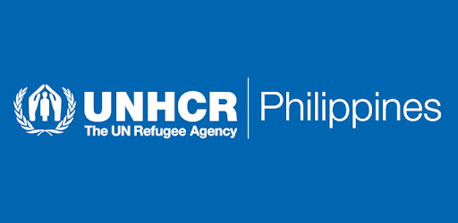

CRI REPORT

**May 2020 | Issue No 6**



|  |
| --- |
| Upon request of the government, UNHCR will ensure provision of core relief items to displaced families. UNHCR will maintain a role as advocate to ensure adherence to the protection principles, including non-discrimination in the provision of aid, and provision of support to displaced persons with specific needs, including women, children or families headed by elderly persons. All distributions will be carried out in coordination and partnership with the local government units, and with partner humanitarian NGOs where feasible |

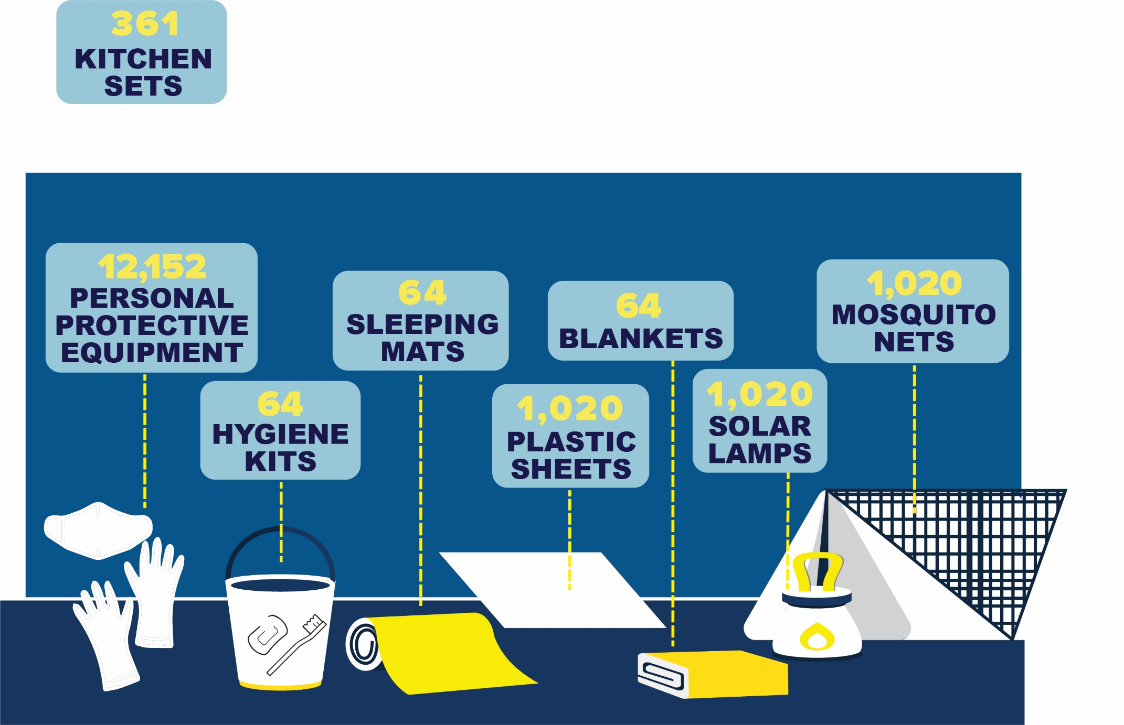

**KEY POINTS**

On 15 May 2020, UNHCR delivered specialized personal protective equipment benefitting a total of **12,152** key government staff who are at the frontline of delivering relief goods and essential services to the communities at risk of contracting the pandemic as well as distributing the emergency subsidy under the Social Amelioration Program. These PPEs comprised of N95 masks, disposable masks and patient care gloves were delivered to the Ministry of Social Services and Development (MSSD) of BARMM and to the Local Government Units (LGU) of Santa Maria, Bulacan and Cainta, Rizal, UNHCR’s partner LGUs in its Cities#WithRefugees campaign.

On 18 May 2020, in partnership with the Community and Family Services International (CFSI), sleeping mats, blankets, hygiene kits, mosquito nets, plastic sheets and solar lamps were provided to 64 families of Pikit, North Cotabato while 901 IDP families have been provided with plastic sheets, mosquito nets and solar lamps. These families fled their places of origin due to a recurring firefight caused by a long-standing dispute between two commanders affiliated with the Moro Islamic Liberation Front (MILF) and Moro National Liberation Front (MNLF).

On 29 May 2020, in coordination with the MSSD-BARMM, plastic sheets, solar lamps and mosquito nets were also provided to 55 displaced families in Malabang, Lanao del Sur. This assistance is in support of MSSD’s work in assisting vulnerable persons on the ground and in enhancing its response to IDPs during the corona virus pandemic.

These CRI distributions took place while the General Community Quarantine (GCQ) was in effect but the activities were still successfully completed with the support from the respective Local Government Units. UNHCR and CFSI, as well as its contracted transporters, have also been granted exemptions to the GCQ restrictions in order to carry out humanitarian missions.

**TOTAL BENEFICIARIES REACHED**



**7,020**

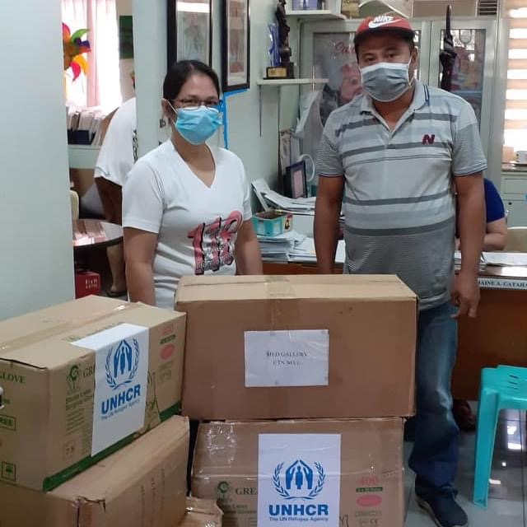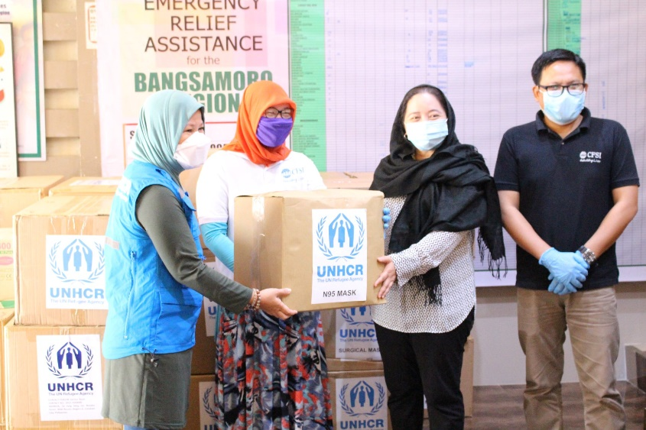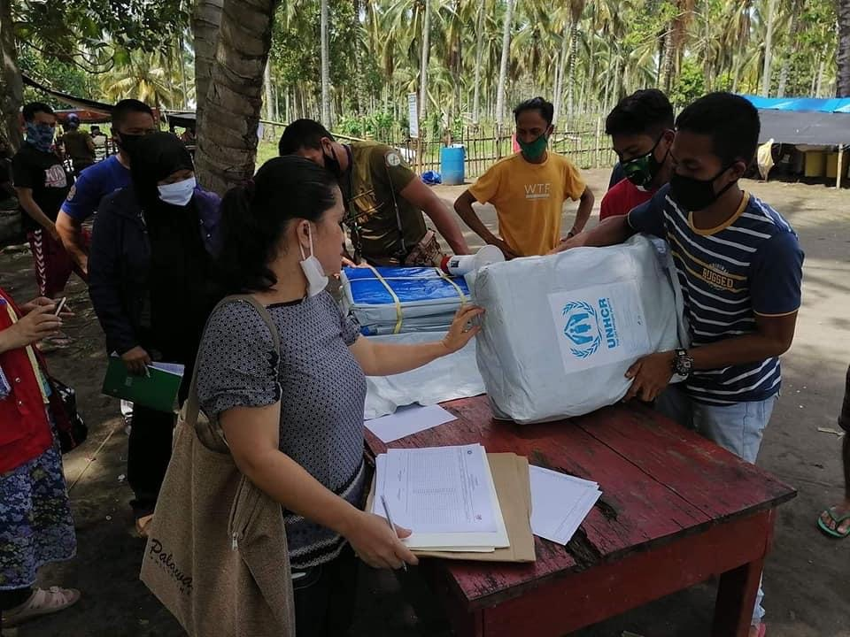

|  |  |  |
| --- | --- | --- |
|  | | |
|  | **Protection Working Group for Bangsamoro Autonomous region in Muslim Mindanao (BARMM)**  In April 2019, PWG for BARMM was established under the leadership of Ministry of Social Services and Development, co-led by UNHCR. The Protection Working Group (PWG), based in Cotabato City, is being convened to support the provision of protection interventions and services to these disaster- and conflict-affected communities. The main objectives of BARMM PWG is to strengthen coordination among relevant actors with a protection role (from regional down to municipal and community level) in order to: (a) ensure timely prevention of and response to protection issues in the BARMM region; and (b) facilitate timely information-sharing among these actors, in support of effective planning and implementation. The PWG meets every 2 months with members of Government agencies with protection roles, Relevant LGUs, UN agencies, Local and International NGOs and CSOs. |  |
| working IN PARTNERSHIP  UNHCR works in partnership with government entities, INGOs, NGOs, CSOs, and UN Agencies, and other organizations. Its primary role is to share information on protection risks and needs and to facilitate coordinated intervention among the various actors involved in IDP protection. UNHCR has project partnership with CFSI, CHR, ACCORD, MMI, KI, TKI, ACTED and IRDT covering Mindanao island including BARMM region. In addition to it’s project partnership, UNHCR works closely with local authorities and Mindanao Humanitarian Actors including:UNICEF **I** IOM **I** OCHA **I** UNDP **I** UNFPA **I** UNHABITAT **I** WFP **I** WHO **I** OXFAM **I** ACTION AGAINST HUNGER **I** CARE **I** UNWOMEN **I** ICRC **I** SAVE THE CHILDREN **I** KFPDI **I** PRC  For more information, please visit the Protection Cluster website[**http://www.protectioncluster.org/philippines/**](https://eur02.safelinks.protection.outlook.com/?url=http%3A%2F%2Fwww.protectioncluster.org%2Fphilippines%2F&data=02%7C01%7Cwahab%40unhcr.org%7C25b0bacd1c134fde29b108d7981c4446%7Ce5c37981666441348a0c6543d2af80be%7C0%7C0%7C637145119492629828&sdata=nafec4jmA8Qq9VFpOeOyabDZy0%2BNDLuf9b8Tv7a8DEk%3D&reserved=0) **or e-mail us at** [**PHICOPRC@unhcr.org**](mailto:PHICOPRC@unhcr.org)  2020 |
|  |
|  |
|  |
| UNHCR MAIN OFFICE  6th Floor, GC Corporate Plaza, 150 Legaspi Street  Legaspi Village, 1229 Makati City, Philippines  UNHCR FIELD OFFICE (COTABATO)  local office address:22 llang llang, Cor, Rosales St.  RH6, 9600 Cotabato City, Philippines  www.unhcr.org |
|  |

